1. **Project Introduction:**
2. Exploratory Data Analysis (EDA) for Real Estate Pricing: Unveiling the Dynamics of House Valuation in a Dynamic Market
3. **Objectives Of the Project:**

1.To collect and clean real estate data from a specific location.

2.To perform exploratory data analysis (EDA) on the collected data to identify key variables that influence property prices.

3.What is the proper encoding technique to be used for ordinal and nominal variables in property price prediction, based on the requirements of the model?

4.To present the findings and insights from the project in a clear and concise manner.

1. **Flow Chart Of Operations:**

Methodology:

1.Data Collection: The first step is to collect data on various features of properties in a specific location.

2.Data Cleaning: The collected data will be preprocessed and cleaned to remove missing values, outliers, and other errors.

3.Exploratory Data Analysis (EDA): The cleaned data will be analyzed using EDA techniques to identify important features that influence property prices.

Various visualizing effects to be shown and data co-relation is to be established.

4.Feature Engineering: After identifying the significant features, new features will be created based on domain knowledge or statistical techniques to enhance the predictive power of the model.

1. **Python Codes**

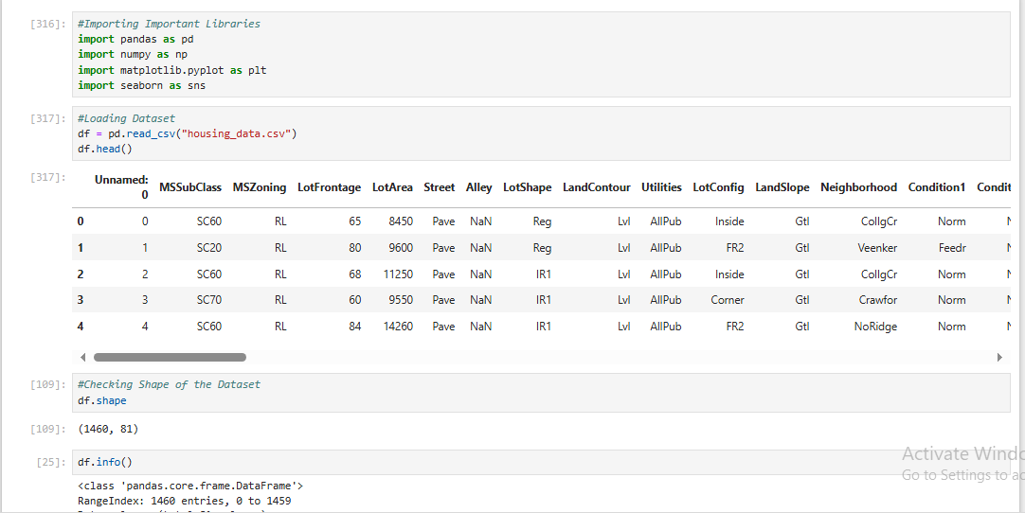

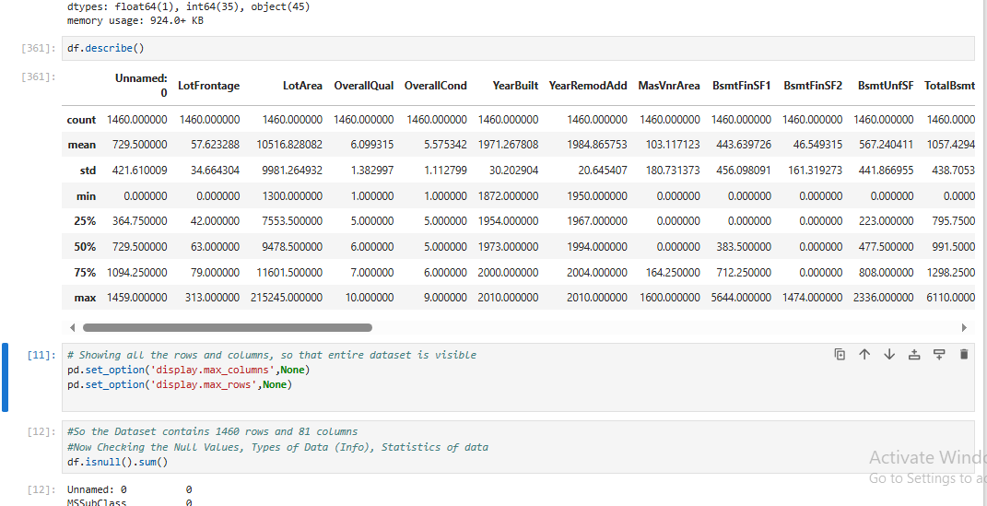

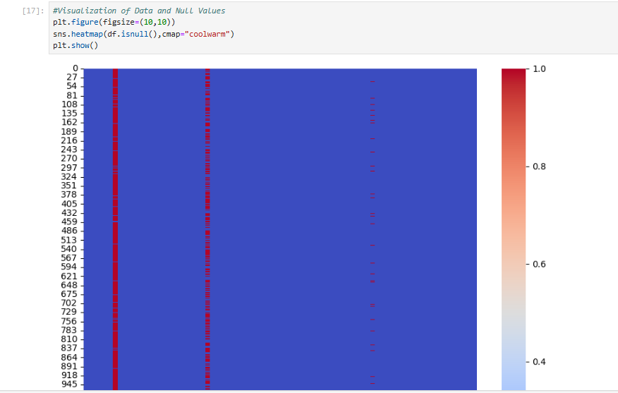

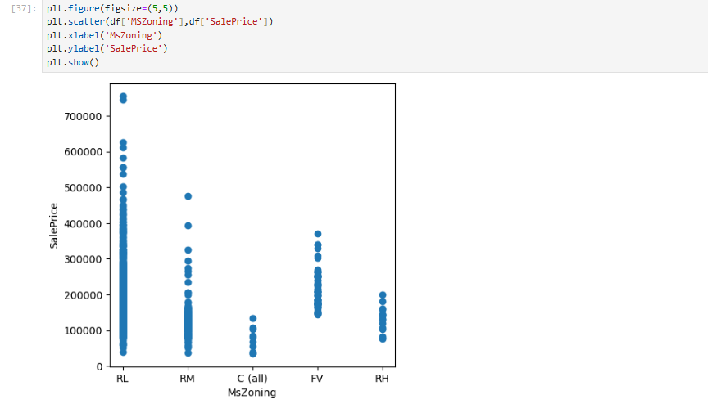



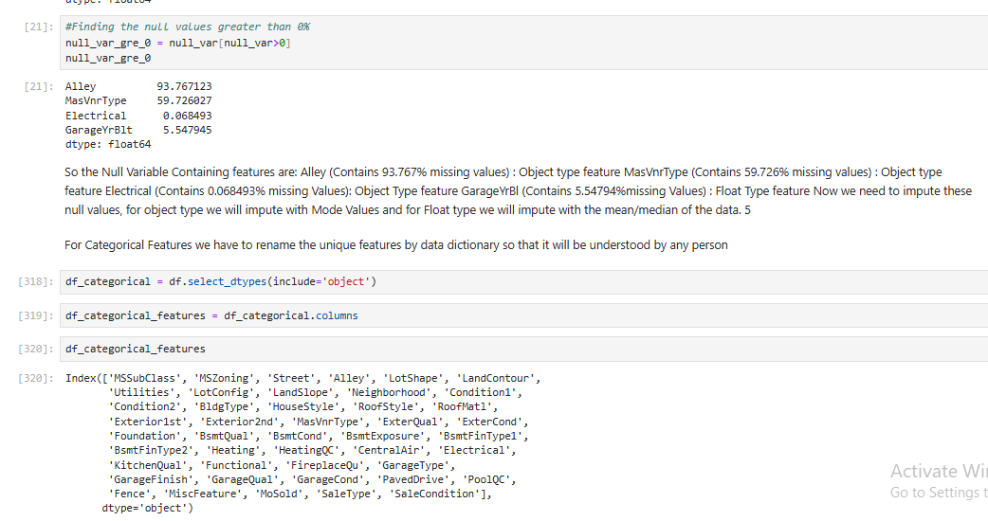

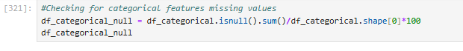

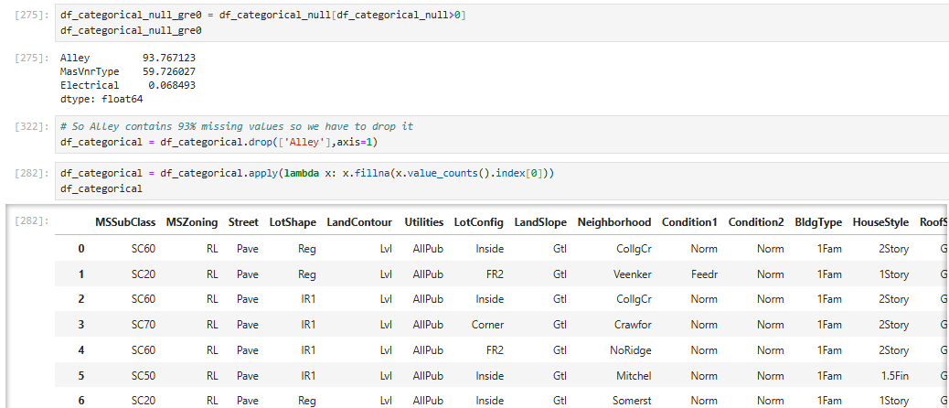

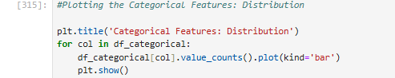

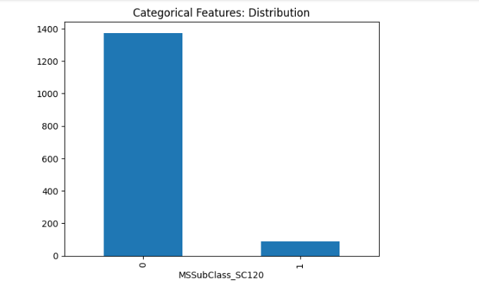

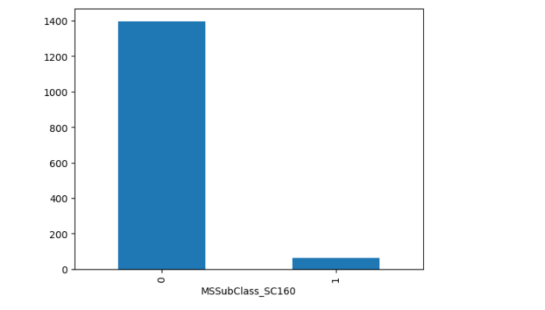

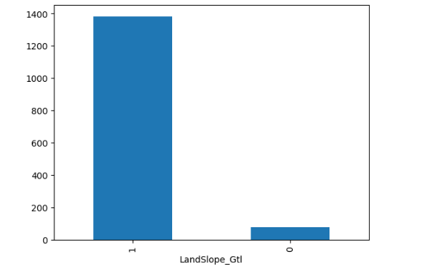

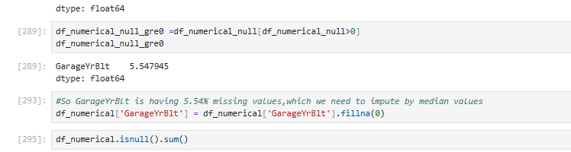



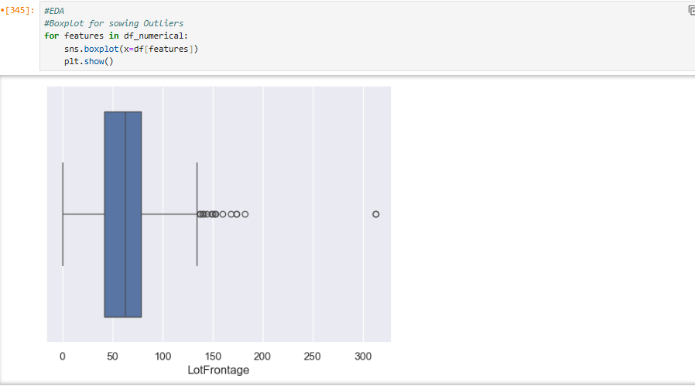

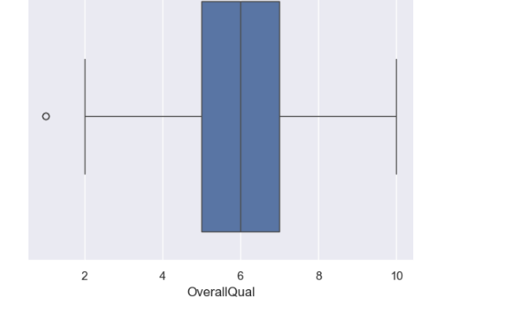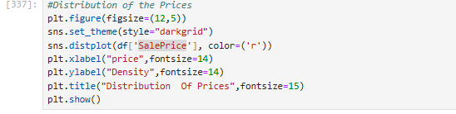

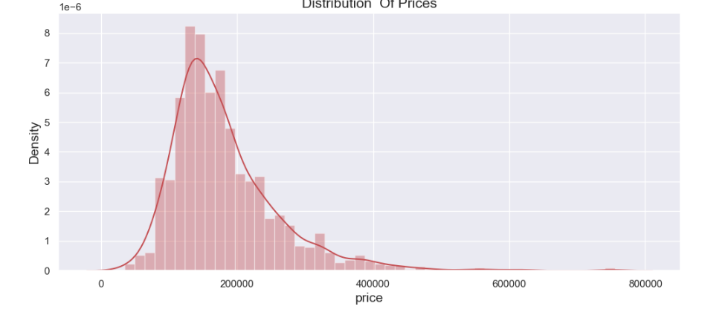

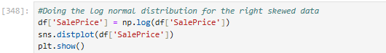

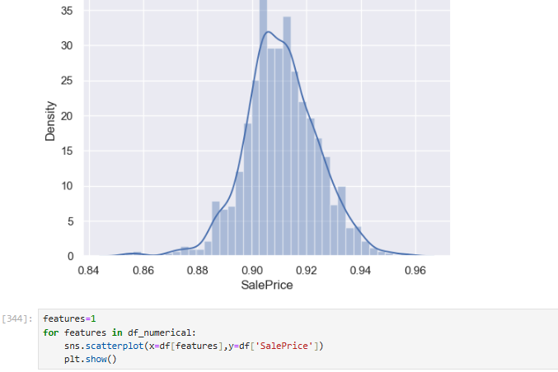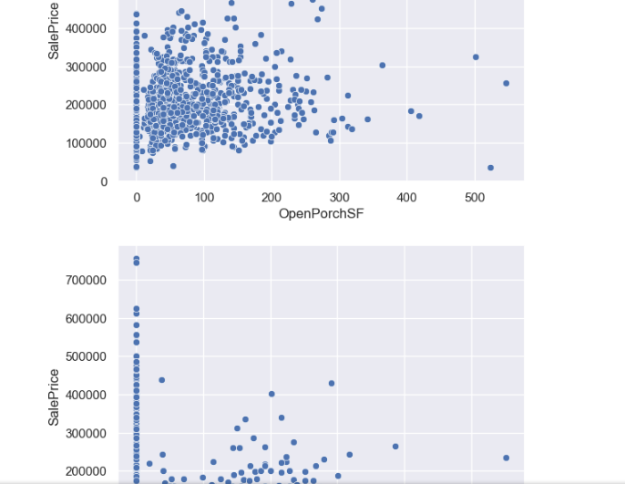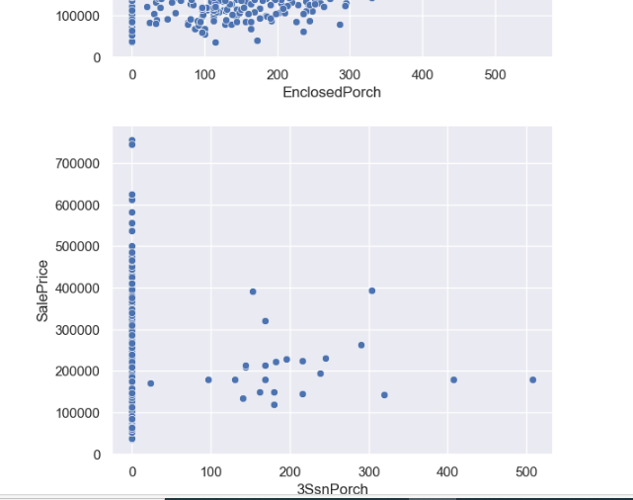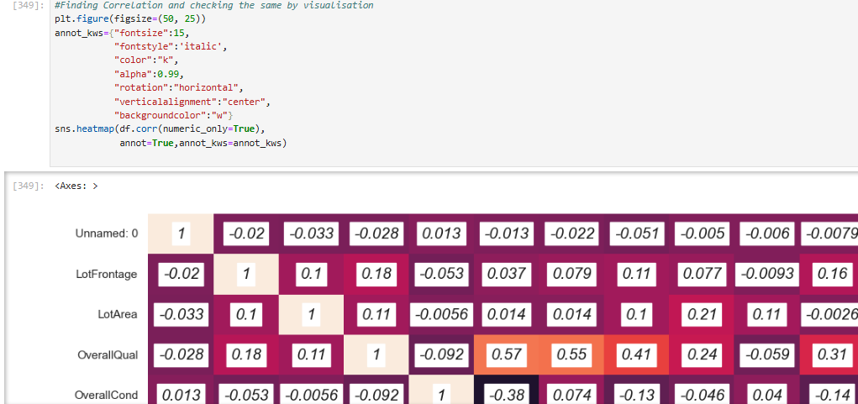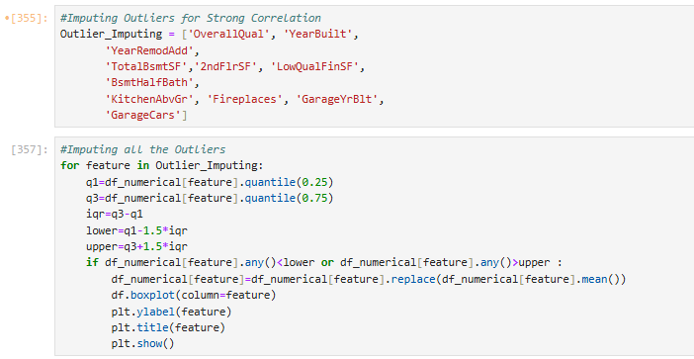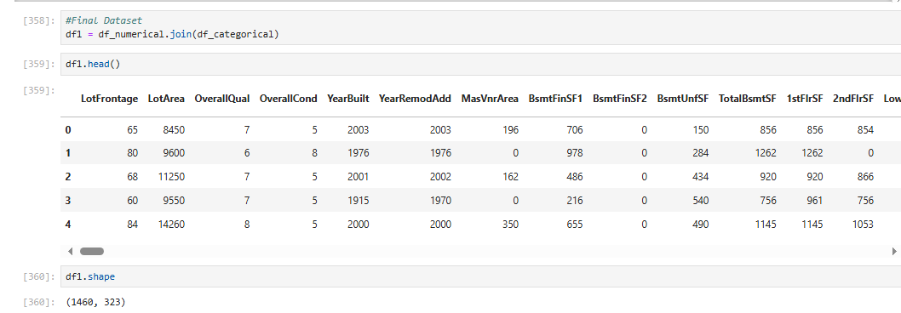

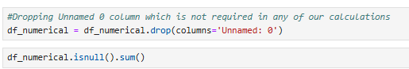

1. **Learning Outcomes**
2. Insights into the significant features that influence property prices in the specific location. 2..A comprehensive report detailing the methodology, results, and insights from the project.
3. **Conclusion**

The project involve collecting and cleaning data, performing EDA, feature engineering. The final outcome will be a comprehensive report detailing the methodology, results, and insights from the project.

1. **Citations- Books and Websites used**

**Used websites: geeksforgeeks,**

**Youtube Videos: Krishna nayer**